FOR DISCRETE DISTRIBUTION:
Q 1) x=(37,42,38,25,31,37,43,37,43,44,28,36,37,51) COMMAND:
x=c(37,42,38,25,31,37,43,37,43,44,28,36,37,51)
m=mean(x)
cat("The mean is:",m,"\n")

me=median(x)
cat("The median is:",me,"\n")

mode<-function(x){ uniqx<-unique(x)
uniqx[which.max(tabulate(match(x, uniqx)))]
}

mo=mode(x)
cat("The mode is:",mo,"\n")

OUTPUT:

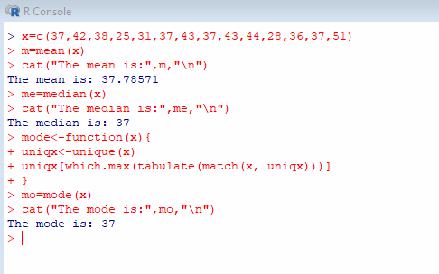

Q 2) y=(23,42,34,25,26,25,18,23,25,41,25,31) COMMAND:
y=c(23,42,34,25,26,25,18,23,25,41,25,31)
m=mean(y)
cat("The mean is:",m,"\n")

me=median(y)
cat("The median is:",me,"\n")

mode<-function(y){ uniqx<-unique(y)
uniqx[which.max(tabulate(match(y, uniqx)))]
}

mo=mode(y)

cat("The mode is:",mo,"\n")

OUTPUT:
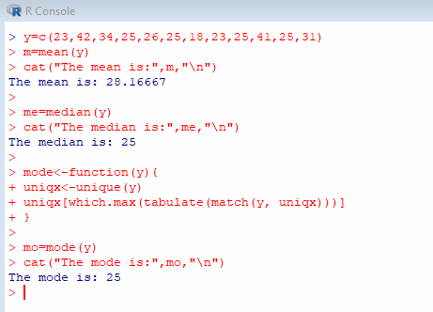

Q1)
x=c(5,10,15,20,25,30,35)
f=c(4,10,22,34,30,21,7)
y=rep(x,f) m=mean(y)
cat("The mean is:",m,"\n")

me=median(y)
cat("The median is:",me,"\n")

mode <- function(x) {

uniqx<- unique(x) uniqx[which.max(tabulate(match(x, uniqx)))]
}
mo=mode(y)
cat("The mode is:",mo,"\n")

OutPut:
> x=c(5,10,15,20,25,30,35)
> f=c(4,10,22,34,30,21,7)
- y=rep(x,f)
- m=mean(y)
- cat("The mean is:",m,"\n") The mean is: 21.52344
- ​
- me=median(y)
- cat("The median is:",me,"\n") The median is: 20
- ​
- mode <- function(x) {
+ uniqx<- unique(x)
+ uniqx[which.max(tabulate(match(x, uniqx)))]
+ }
- mo=mode(y)

- cat("The mode is:",mo,"\n") The mode is: 20

Q2.
x=c(12,14,16,18,20,22,24,26,30,32)
f=c(8,15,28,32,46,35,24,15,10,6)
y=rep(x,f) m=mean(y)
cat("The mean is:",m,"\n")

me=median(y)
cat("The median is:",me,"\n")

mode <- function(x) { uniqx<- unique(x)
uniqx[which.max(tabulate(match(x, uniqx)))]
}
mo=mode(y)
cat("The mode is:",mo,"\n")

OutPut:
- x=c(12,14,16,18,20,22,24,26,30,32)
- f=c(8,15,28,32,46,35,24,15,10,6)
- y=rep(x,f)
- m=mean(y)

- cat("The mean is:",m,"\n") The mean is: 20.44749
- ​
- me=median(y)
- cat("The median is:",me,"\n") The median is: 20
- ​
- mode <- function(x) {
+ uniqx<- unique(x)
+ uniqx[which.max(tabulate(match(x, uniqx)))]
+ }
- mo=mode(y)
- cat("The mode is:",mo,"\n") The mode is: 20
- ​

